ELEC 4700 Assignment 1

Monte-Carlo Modeling of Electron Transport

Written by:

Andrew Branicki (100973961)

February 3rd. 2019

Part 1: Electron Modelling

The first part of this assignment involves modelling a group of electron as particles inside of silicon. The effective mass of the electrons is given as 0.26m0, and the dimensions of the modelled region are given as 200 nm x 100 nm.

Assuming the temperature is 300K, the thermal velocity of the electrons is given by:

The mean time between collisions is given as τmn = 0.2 ps, meaning the mean free path of the electrons (the average amount of time they can travel without a collision) is given by:

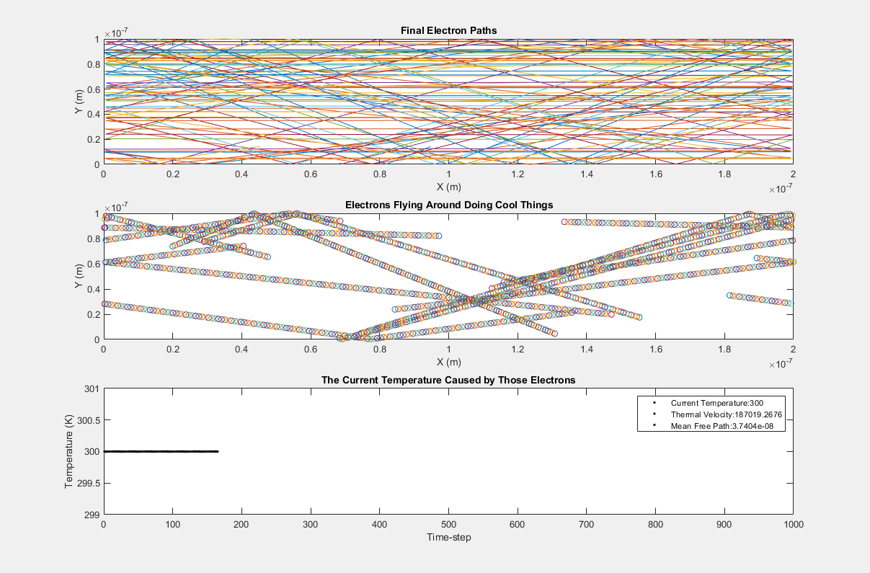Electrons are generated with a random initial position and angle, with a fixed velocity given by Vth. The electrons are then animated to move around the confined region, with their paths animated:

Figure : Modelling Electrons in the Silicon (Mid-Animation)

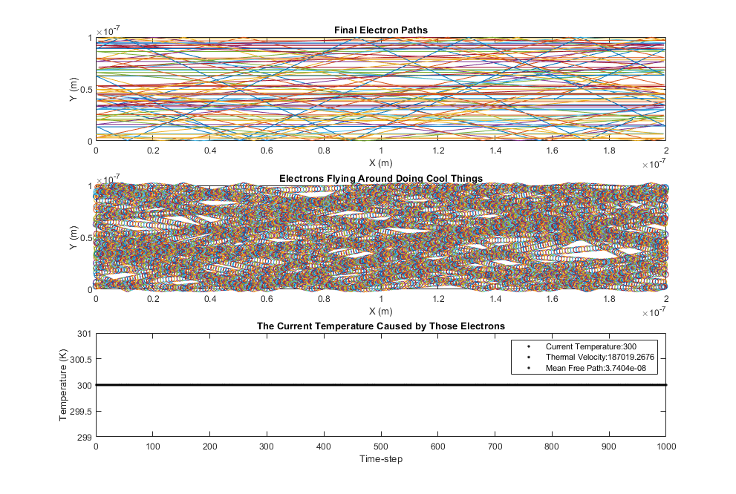The top plot in Figure 1 shows the final simulated paths of 10 electrons. The middle plot shows an animation of the electron paths over time, and can be run with the attached MATLAB code. Lastly, the bottom plot shows the change in temperature over time as the electrons bounce around the box. Figure 2 below shows the plots at the end of the animation:

Figure 2: Modelling Electrons in the Silicon (End of Animation)

As seen in Figure 2 above, the temperature stays at a constant 300K throughout the simulation, as defined by the equation for thermal velocity. Since the velocity of every particle is simply given as the thermal velocity, there will be no variation in the temperature plot.

Part 2: Collisions with Mean Free Path (MFP)

In the second part of the assignment, the velocities of each electron were no longer given as the thermal velocity. Instead, a Maxwell-Boltzmann distribution was used for the electrons simulated, with their average equaling the thermal velocity at 300K. An example histogram for 1000 electrons can be seen in Figure 3 below:



Figure 3: Maxwell-Boltzmann Distribution for Electron Velocities, with Average Equalling the Thermal Velocity at 300K

Additionally, a scattering mechanic was implemented where every electron has a probability to scatter and have a new random velocity assigned to it. The scattering probability is given by:

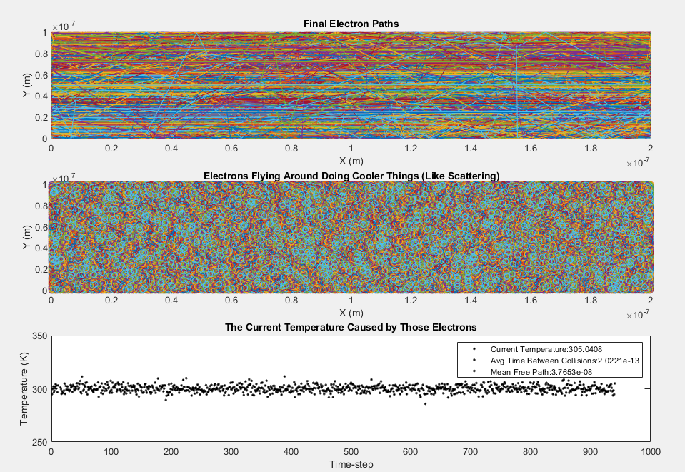The simulation for 1000 electrons can be seen below:

Figure 4: 1000 Electrons-in-a-Box with Scattering and a Uniform Distribution of Velocities with Average = Vth at 300K

As seen in Figure 4 above, the temperature does not remain at a constant 300K anymore. Instead, it is centered around 300K but fluctuates approximately 5 degrees higher and lower. This is explained by the uniform distribution of velocities with an average of the thermal velocity at 300K. Particles with slower and higher thermal velocities will have smaller and larger temperatures respectively.

However, the average time between collisions remains constant at 2.0221 x 10-13 seconds, and the mean free path stays at 3.7653 x 10-8 seconds.

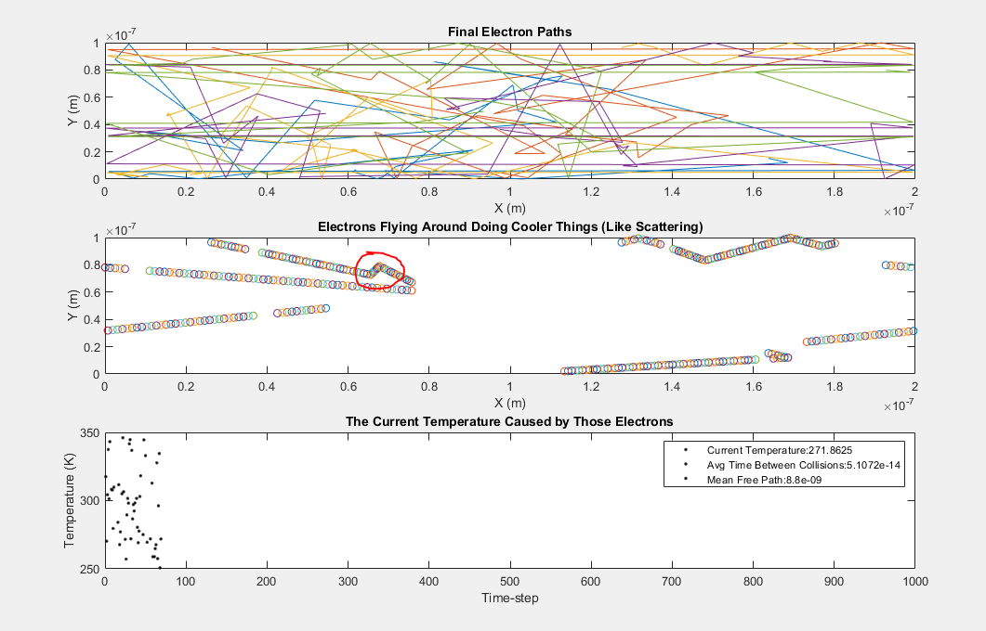An example of an electron scattering can be seen in Figure 5 below:

Figure 5: Electron Scattering Example

Since a new random velocity is given to a particle when it scatters, scattering can be detected when a particle decides to completely change its direction.

Additionally, it can be seen in Figure 5 that having fewer particles (in this case, only five) will result in a much greater variation in the temperature. This is because there are not enough particles to form a uniform distribution with the average set to the thermal velocity at 300K.

Part 3: Enhancements

The last part of the assignment involves adding a few extra features to the simulations in Part 2. In this case, two small boxes were added to the middle of the canvas which created a bottle neck.

As before, the electrons were simulated with scattering effects and with a uniform distribution centered at the thermal velocity at 300K. When an electron hits the bottle neck boxes, it will bounce off similar to the edges of the canvas.

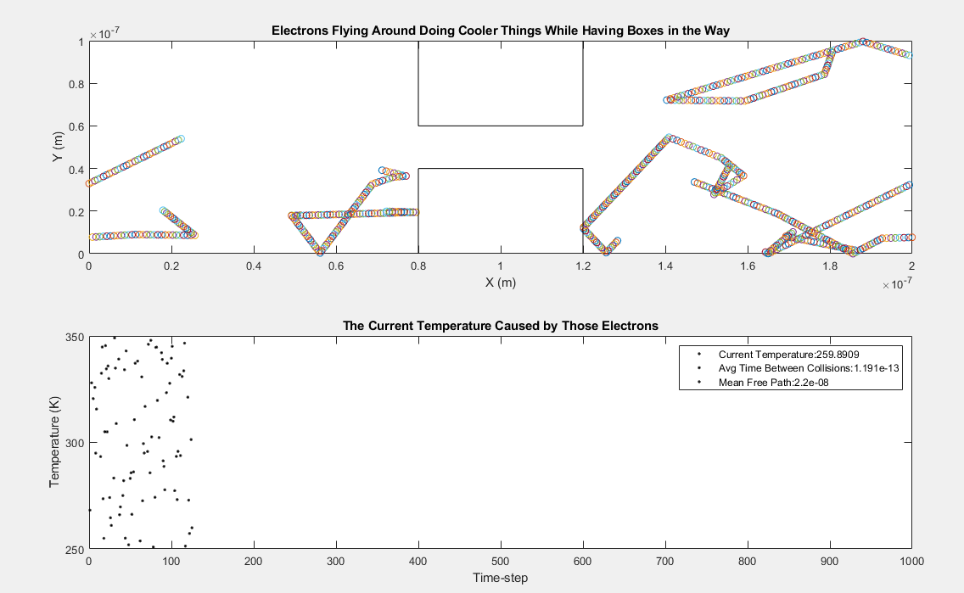A simulation with five electrons can be seen below in Figure 6:

Figure 6: Electrons Simulated with Scattering and Boxes in the Way

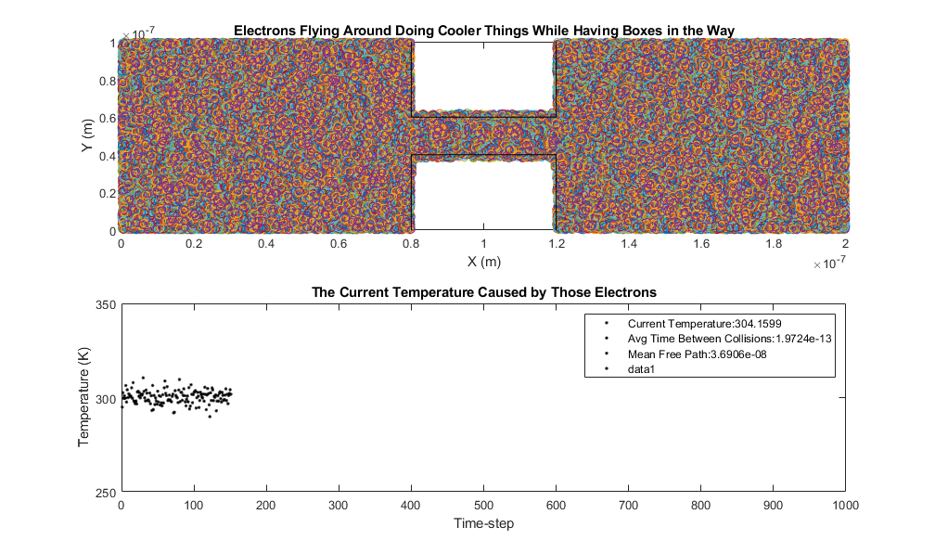A simulation of 1000 electrons can be seen in Figure 7 below:

Figure 7: 1000 Electrons Simulation with Boxes in the Way

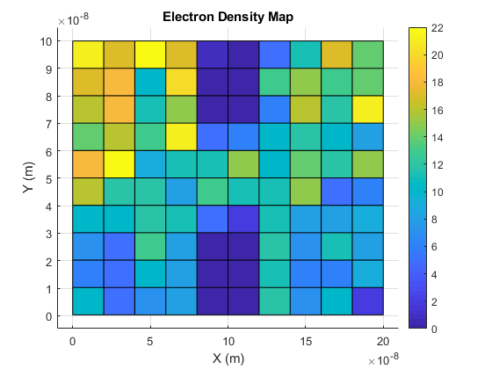The resulting electron density map from the simulation in Figure 7 can be seen below:

Figure 8: Electron Density Map

The corresponding temperature map can be seen below:

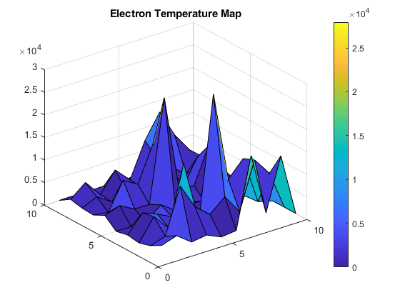

Figure 9: Electron Temperature Map